Battery Programming Box Fixture Cables

Connectors
5 Pin 2.0mm JST-PH Connector or compatible

Male (Programming box) Female (Battery fixture)
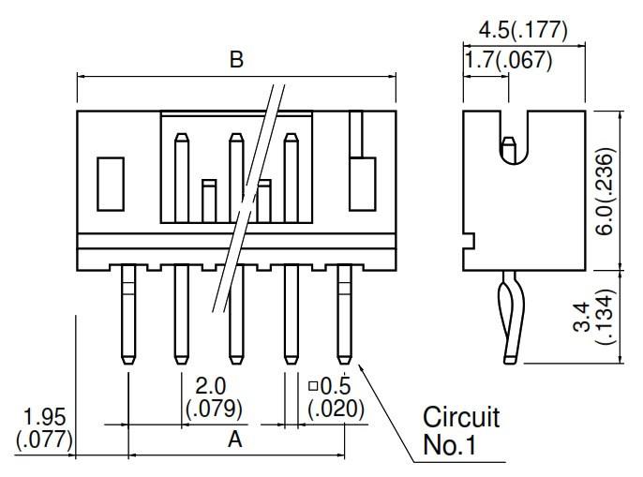
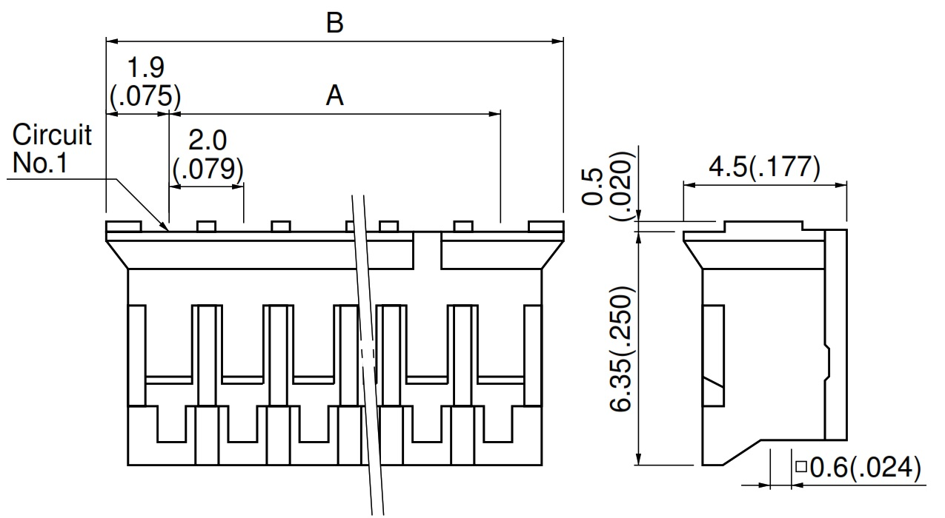

Pinout
Pin | Signal
1 | Batt+
2 | SCL
3 | SDA
4 | GND
5 | Themistor

